2D TRANSFORMATION

include<GL/glut.h>
#include<GL/gl.h>
#include<math.h>
#include<stdio.h>

int A[20][3],C[20][3],tx,ty,sx,sy,shx,shy,n;
float B[3][3];

void lineDDA(int x1,int y1,int x2, int y2);
void translation();
void scaling();
void shearing();
void rotation();
void reflection();
void multiply();
void display();
void unit();

void lineDDA(int x1,int y1,int x2, int y2)
{

int i,dx,dy,steps;
float incx,incy,x,y;
dx=x2-x1;
dy=y2-y1;
if(abs(dx)>abs(dy))
{
steps=abs(dx);
}
else
{
steps=abs(dy);
}
incx=(float)dx/steps;
incy=(float)dy/steps;
x=x1;
y=y1;

glBegin(GL_POINTS);
glVertex3f(x,y,0.0);

for(i=0;i<steps;i++)
{
x=x+incx;
y=y+incy;
glVertex2f(round(x),round(y));

}
glEnd();

}

void unit()
{
int i,j;
for(i=0;i<3;i++)
{
for(j=0;j<3;j++)
{
if(i==j)
B[i][j] = 1;
else
B[i][j] = 0;
}
}
}

void translation()
{
printf("\nEnter the value of tx and ty");
scanf("%d%d", &tx,&ty);
unit();
B[2][0] = tx;
B[2][1] = ty;
multiply();
}

void scaling()
{
printf("\nEnter the value of sx and sy");
scanf("%d%d", &sx,&sy);
unit();
B[0][0] = sx;
B[1][1] = sy;
multiply();
}

void shearing()
{
int ch;
printf("\nEnter the choice");
printf("\n1: X-axis");
printf("\n2: Y-axis");
printf("\n3: XY line");
scanf("%d", &ch);
unit();
if(ch == 1)
{
printf("\nEnter the value of shx");
scanf("%d", &shx);
B[1][0] = shx;
multiply();
}
else if (ch == 2)
{
printf("\nEnter the value of shy");
scanf("%d", &shy);
B[0][1] = shy;
multiply();
}
else if(ch == 3)
{
printf("\nEnter the value of shx");
scanf("%d", &shx);
B[1][0] = shx;
printf("\nEnter the value of shy");
scanf("%d", &shy);
B[0][1] = shy;
multiply();

}

else
printf("Wrong input");
}

void rotation()
{
float t;
printf("\nEnter the value of angle");
scanf("%f", &t);
unit();
B[0][0] = B[1][1] = cos(t);
B[1][0] = -sin(t);
B[0][1] = sin(t);
multiply();
}

void reflection()
{
int ch;
printf("\nEnter the choice");
printf("\n1: About X-axis");
printf("\n2: About Y-axis");
printf("\n3: About X=Y line");
printf("\n4: About X=-Y line");
scanf("%d", &ch);
unit();
if(ch == 1)
{
B[1][1] = -1;
multiply();
}
else if(ch == 2)
{
B[0][0] = -1;
multiply();
}
else if(ch == 3)
{
B[0][0] = B[1][1] = 0;
B[0][1] = B[1][0] = 1;
multiply();
}
else if(ch == 4)
{
B[0][0] = B[1][1] = 0;
B[1][0] = 1;
B[0][1] = -1;
multiply();
}
else
printf("\nWrong Input");
}
void multiply()
{
int i,j,k;
for(i=0;i<n;i++)
{
for(j=0;j<3;j++)
{ C[i][j] =0;
for(k=0;k<3;k++)
{
C[i][j]+= A[i][k]*B[k][j];
}
}
C[i][2] = 1;
}
for(i=0;i<n;i++)
{
for(j=0;j<3;j++)
{
printf("\n%d %d", A[i][j], C[i][j]);
}
}
}

void Init()
{
glClearColor(1.0,1.0,1.0,0.0);

gluOrtho2D(0,640,0,480);
}

void display()
{
int i;
glClear(GL_COLOR_BUFFER_BIT);
glColor3f(1.0,0.0,0.0);
lineDDA(320,0,320,480);
lineDDA(0,240,640,240);

glColor3f(0.0,0.0,1.0);
for(i=0;i<n-1;i++)
lineDDA(A[i][0]+320,A[i][1]+240,A[i+1][0]+320,A[i+1][1]+240);
lineDDA(A[n-1][0]+320,A[n-1][1]+240,A[0][0]+320,A[0][1]+240);

glColor3f(0.0,1.0,0.0);
for(i=0;i<n-1;i++)
lineDDA(C[i][0]+320,C[i][1]+240,C[i+1][0]+320,C[i+1][1]+240);
lineDDA(C[n-1][0]+320,C[n-1][1]+240,C[0][0]+320,C[0][1]+240);

glFlush();
}

int main(int argc,char **argv)
{
int i,ch;
printf("\nTRANSFORMATIONS");
printf("\nEnter your choice");
printf("\n1-> Translation");
printf("\n2-> Scaling");
printf("\n3-> Shearing");
printf("\n4-> Rotation");
printf("\n5-> Reflection");
scanf("%d", &ch);
printf("\nEnter the number of vertices");
scanf("%d", &n);
for(i=0;i<n;i++)
{

printf("\n enter the values of (x%d,y%d):\n", i+1, i+1);
scanf("%d%d",&A[i][0],&A[i][1]);
A[i][2] = 1;
}
switch(ch)
{
case 1: translation();
break;
case 2: scaling();
break;
case 3: shearing();
break;
case 4: rotation();
break;
case 5: reflection();
break;
default:
printf("\nWrong Input");
}
glutInit(&argc,argv);
glutInitDisplayMode(GLUT_SINGLE | GLUT_RGB);
glutCreateWindow("Transformation");
glutInitWindowPosition(0,0);
glutInitWindowSize(640,480);
Init();

glutDisplayFunc(display);
glutMainLoop();
return 0;
}

OUTPUT:
1.TRANSLATION

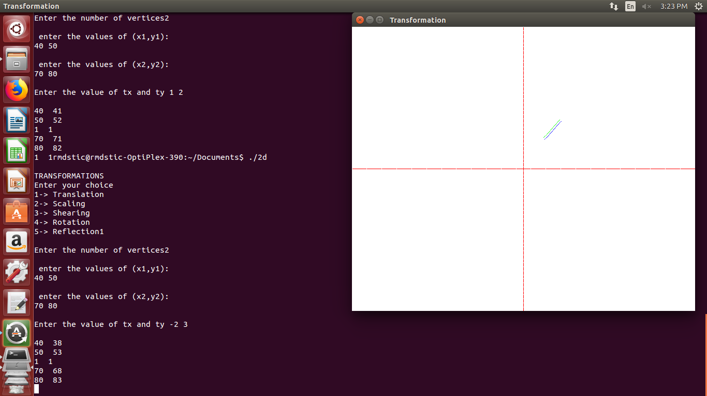

2.SCALING

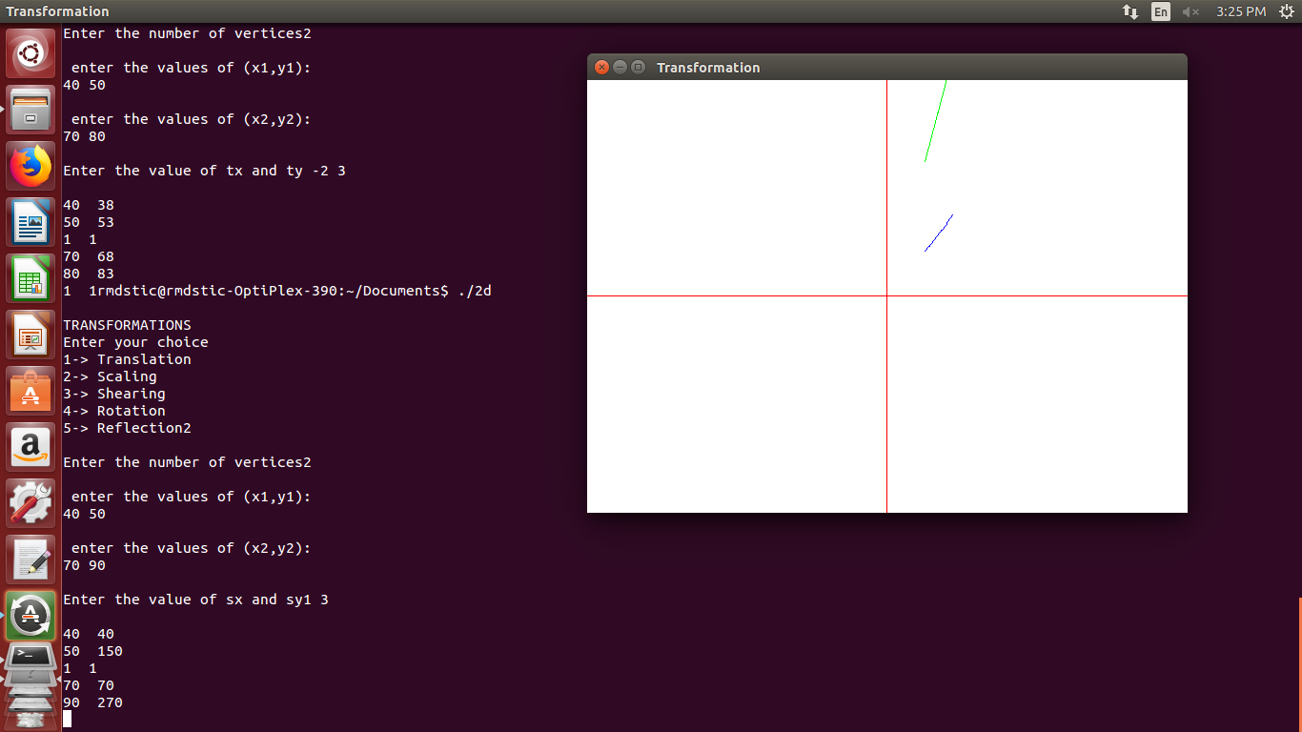

3.SHEARING :

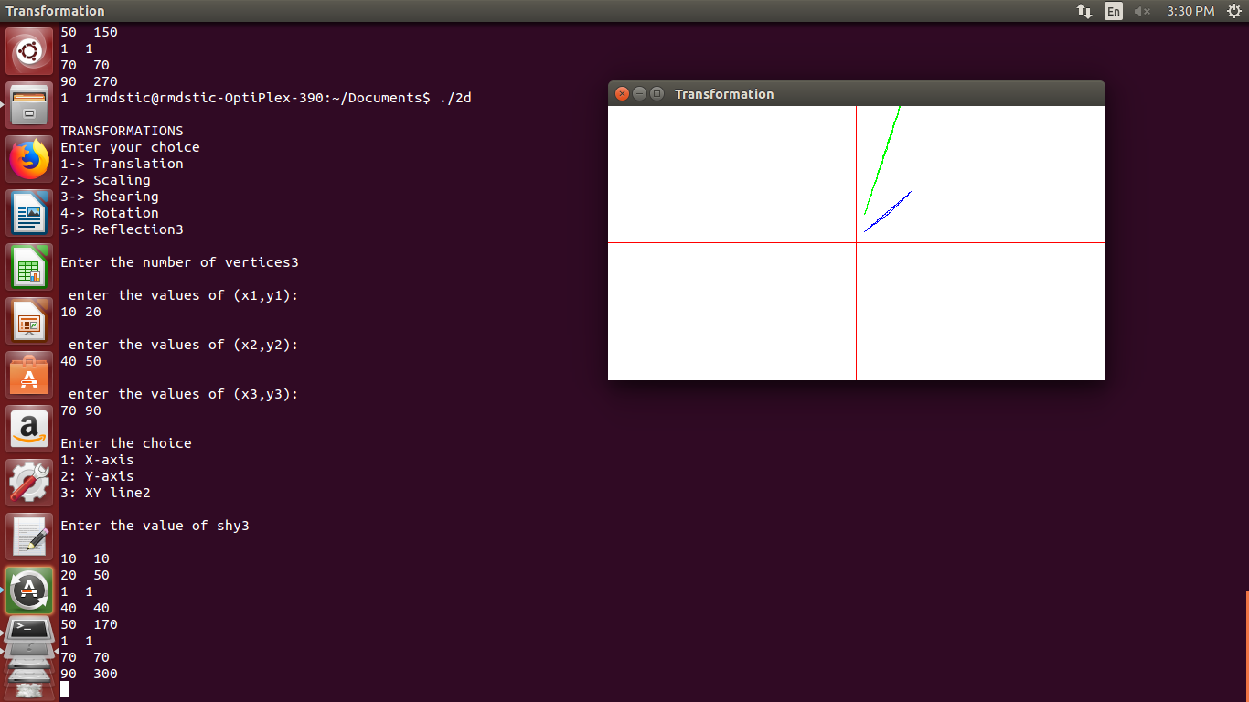

4.ROTATION :
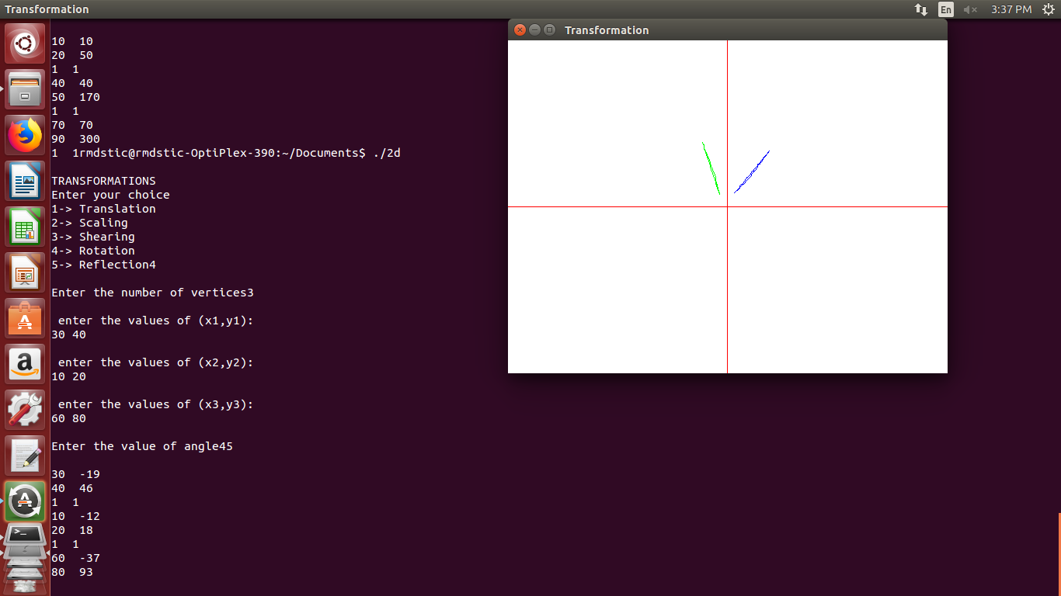
5.REFLECTION :

